

**ALY6980**

**Capstone Project**

**Winter 2024**

**Google Vertex AI Documentation**

**By**

**Group 5**

**Introduction**

Welcome to the Google Vertex AI Documentation! This comprehensive guide aims to equip you with a deep understanding of Google Vertex AI, an advanced platform tailored to streamline and enhance the machine learning (ML) development lifecycle. Whether you're an aspiring data scientist, a seasoned ML practitioner, or a business seeking to leverage the power of AI, this documentation will serve as your roadmap to unlocking the full potential of Vertex AI.

**Understanding the Basics**

At the core of Google Vertex AI lies the profound field of machine learning (ML) and artificial intelligence (AI). ML enables computers to learn from data patterns and make predictions or decisions without explicit programming. Within ML, various paradigms exist, including supervised learning (where models are trained on labeled data), unsupervised learning (where models uncover hidden patterns in unlabeled data), and reinforcement learning (where models learn through trial and error).

**Exploring Google Vertex AI**

Google Vertex AI emerges as a cutting-edge platform engineered to democratize AI by simplifying the complexities of ML model development and deployment. It serves as a unified interface encompassing a suite of tools and services tailored to meet diverse ML needs, from data preprocessing to model training, evaluation, deployment, and management. Moreover, Vertex AI integrates AutoML capabilities, empowering users to create custom ML models with minimal manual intervention.

**Getting Started**

Embarking on your journey with Google Vertex AI begins with the establishment of a Google Cloud account and the creation of a project within the Google Cloud Console. By enabling the Vertex AI API, you gain access to a plethora of ML services and functionalities, setting the stage for your exploration and utilization of Vertex AI's robust capabilities.

**Data Preparation**

Central to any successful ML endeavor is the meticulous preparation of data. This involves curating and preprocessing datasets to ensure they are appropriately formatted, labeled, and free from anomalies. Google Vertex AI facilitates this process by providing seamless integration with Google Cloud Storage (GCS), where datasets can be stored, accessed, and utilized for training and inference tasks.

**Model Development**

In the realm of ML, model development serves as the cornerstone of innovation. Google Vertex AI empowers users to unleash their creativity by offering support for various ML frameworks, including TensorFlow, PyTorch, and scikit-learn. Through a unified interface, users can embark on the journey of model creation, experimenting with diverse architectures, hyperparameters, and optimization strategies to achieve optimal performance.

**AutoML**

For users seeking a more streamlined approach to ML model development, Google Vertex AI's AutoML capabilities provide a compelling solution. AutoML Vision, Natural Language, and Tables offer pre-trained models and automated training pipelines tailored to specific use cases, enabling users to harness the power of ML without the need for extensive domain expertise.

**Monitoring and Optimization**

As ML models evolve and adapt to changing environments, continuous monitoring and optimization become imperative. Google Vertex AI offers robust monitoring tools that track key metrics such as accuracy, latency, and model drift, empowering users to gain insights into model performance and identify areas for improvement. Through iterative optimization processes, users can fine-tune hyperparameters, retrain models, and enhance overall efficacy.

**Deployment and Scaling**

The culmination of the ML journey lies in the deployment and scaling of trained models. Google Vertex AI simplifies this process by providing seamless deployment capabilities, enabling users to deploy models as endpoints for real-time inference. Leveraging Google Cloud's infrastructure, deployments can seamlessly scale to accommodate fluctuating demand, ensuring reliable and scalable ML solutions.

**Cost Management**

In the pursuit of ML innovation, effective cost management is essential. Google Vertex AI offers transparent pricing models and comprehensive cost management tools, enabling users to monitor usage, estimate expenses, and optimize costs associated with training, deployment, and inference tasks. By leveraging these tools, users can achieve cost-efficient ML solutions without compromising on performance or scalability.

**Community and Support**

The journey with Google Vertex AI is enriched by a vibrant community of users, experts, and enthusiasts. Through participation in Google Cloud forums, discussion groups, and events, users can engage with peers, share insights, and seek guidance on ML-related topics. Additionally, Google Cloud offers extensive documentation, tutorials, and support resources, ensuring users have access to the knowledge and assistance needed to navigate their ML endeavors successfully.

**Snapshots:**

* Importing the dataset.

* Setting proper parameters and running the best model for the dataset.

* After completing the training of brain tumor dataset, selecting the Alzheimer dataset.

* Getting the results on the dataset

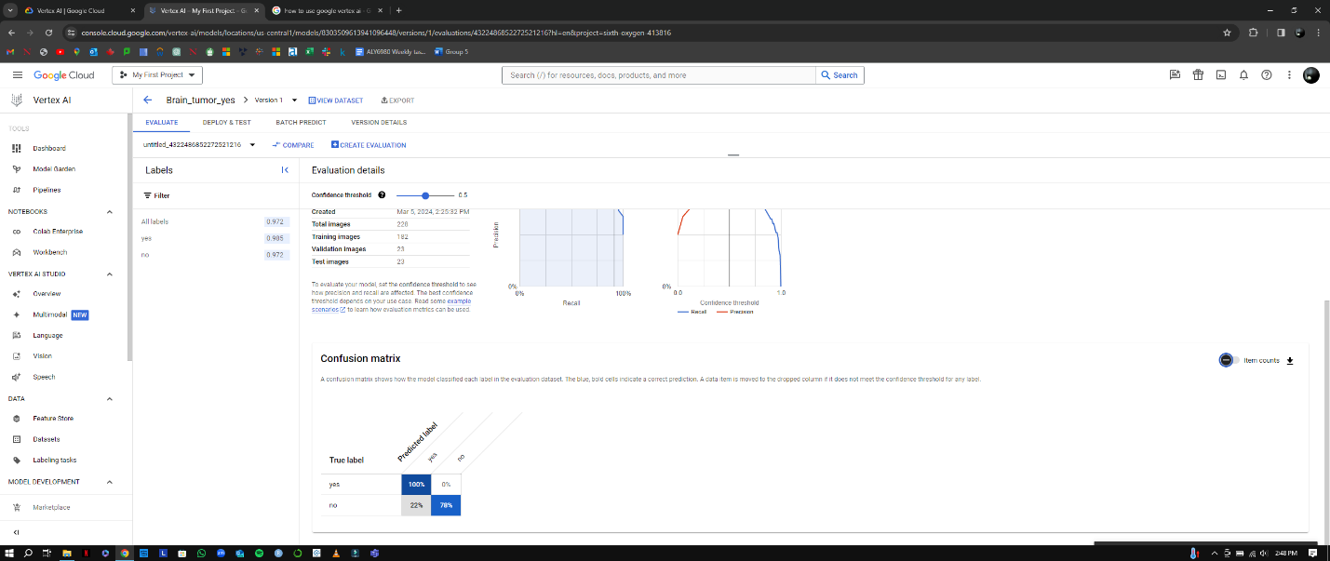

* Testing the dataset on the model has the best accuracy.

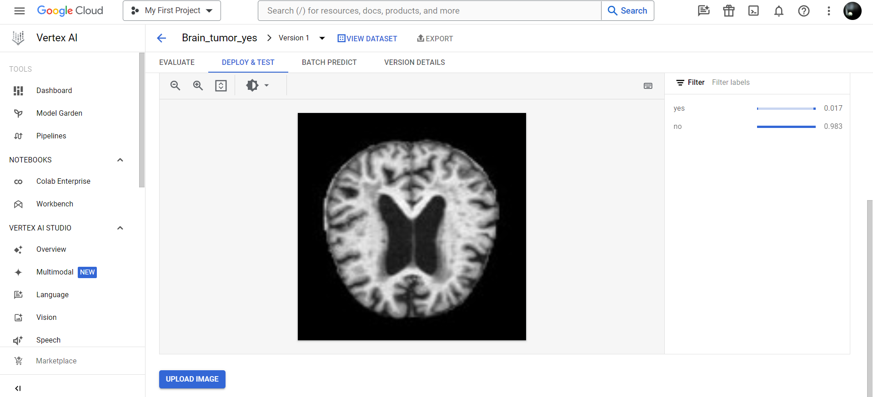

* Example of model detecting if the patient had brain tumor or not.

